Hands-on Activities
for the Whole Family!

Please join us for
Family
Energy!

discover
Learn
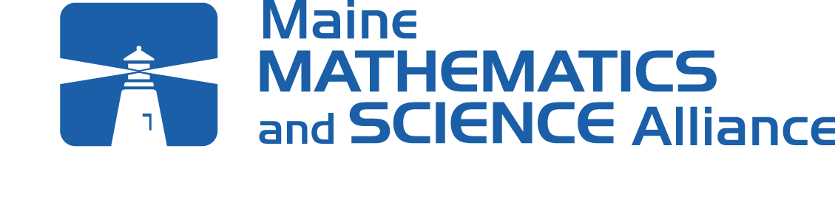

Date: Time: Time:
Place:

Measure
- Children in grades ___ and their families explore energy together
- Learn how to save money at home by using energy wisely

Student Name:
Parent Name:
Contact Number:
Teacher Name:

improve

COMPARE
find phantom
Loads

